**Ideation Phase**

**Define the Problem Statements**

|  |  |
| --- | --- |
| Date | 19 September 2022 |
| Team ID | PNT2022TMID48097 |
| Project Name | Project – Real Time Communication Using AI For Specially Abled Person. |
| Maximum Marks | 2 Marks |

**Customer Problem Statement Template:**

Create a problem statement to understand your customer's point of view. The Customer Problem Statement template helps you focus on what matters to create experiences people will love.

A well-articulated customer problem statement allows you and your team to find the ideal solution for the challenges your customers face. Throughout the process, you’ll also be able to empathize with your customers, which helps you better understand how they perceive your product or service.

|  |  |
| --- | --- |
| **I am** | Disabled person who face lots of difficulty in day to day life. |
| **I am trying to** | Work like others and feel happy by forgetting my inabilities. |
| **But** | I feel frustrated by thinking my inability. |
| **Because** | Job dissatisfaction make to remain my disability. |
| **Which makes me feel happy** | I am feel very happy when the society recognised me and feel extremely happy when I get right job according to my knowledge and my ability. |

Reference: <https://miro.com/app/board/uXjVPTes3NU=/?share_link_id=210887399489>}

**Example:**

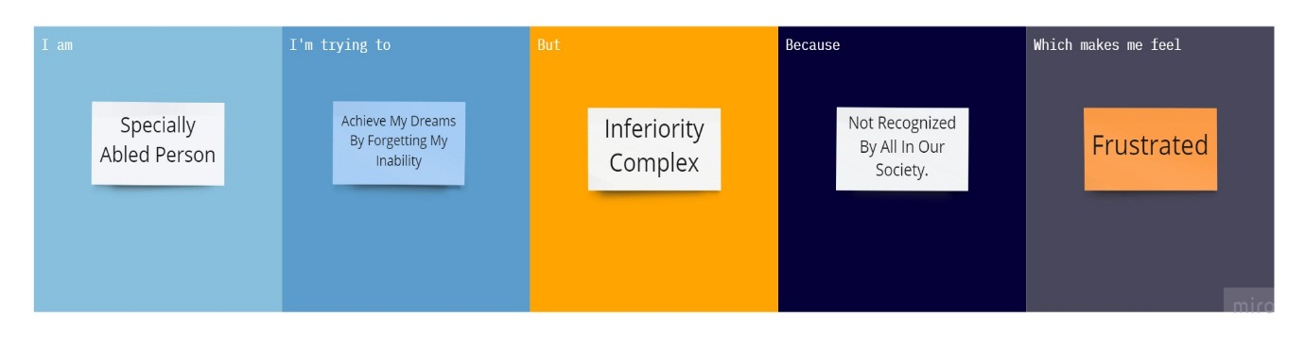

|  |  |  |  |  |  |
| --- | --- | --- | --- | --- | --- |
| **Problem Statement (PS)** | **I am (Customer)** | **I’m trying to** | **But** | **Because** | **Which makes me feel** |
| PS-1 | Disabled person who face lots of difficulty in day to day life. | Work like others and feel happy by forgetting my inabilities. | I feel frustrated by thinking my inability. | Job dissatisfaction make to remain my disability. | I am feel very happy when the society recognised me and feel extremely happy when I get right job according to my knowledge and my ability. |

|  |  |  |  |  |  |
| --- | --- | --- | --- | --- | --- |
|  |  |  |  |  |  |
| PS-2 | Specially abled person struggling with dreams. | Achieve my dreams | I have inferiority complex | I feel disappointed with my inability. | When I achieve my dreams I feel extremely happy. |